RAI VALLEY AREA SCHOOL

2015

11201
2201

202020155
2222222015

O te Awaawa O Rai

CHARTER

291
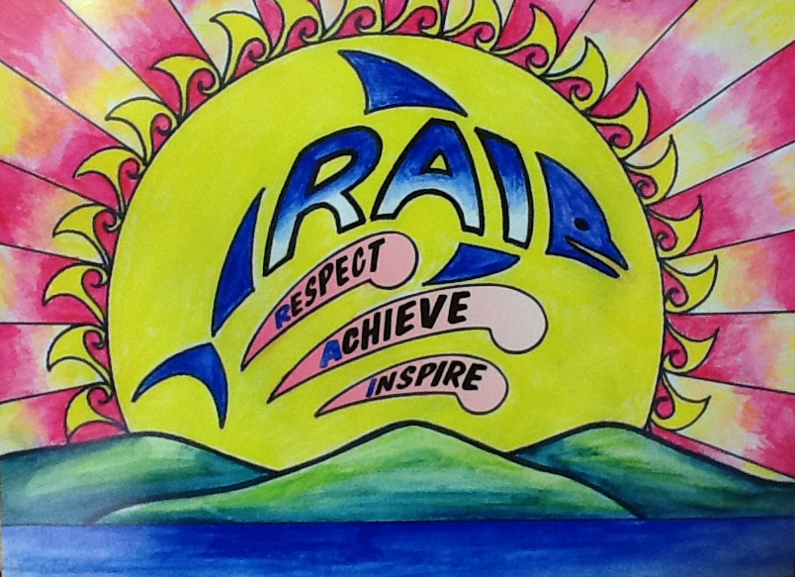

2018

CONTENTS | PAGE  1
SECTION A
Our Mission Statement | 2
Description of our School and Community | 3
Strategic Goals | 4
Maori Achievement Statement | 5
Special Needs/Abilities Achievement Statement | 6
The RAI Way | 7
Strategic Plan for 2018 - 2020
Strategic Goals | 8-9
Annual Targets 2018 | 10
Change and Improvement Plan for RVAS | 11-16
Community of Learning Achievement Targets | 17-36
Table of Contents

Appendix
1.Charter Consultation | 6.Curriculum Development
2.National Education Goals | 7.Curriculum Development Action Plan
3.Supporting Documentation | 8. Five Year Programme of Self Review
4.Annual Timeline | 9. School Development Plan
5.Procedural Information

1

Growing and Learning towards a Great Future

Growing and Learning towards a Great Future

At Rai Valley Area School/O te Awaawa O Rai our Mission Statement is:

Growing and Learning towards a Great Future

Rai Valley Area School aims to provide quality education that
caters for the needs of individual students.

We aim to achieve this by:

Continually developing classroom programmes that are closely aligned to the National Curriculum statements and emphasis the teaching of the Key Competencies.
We will develop a love of learning by promoting The Rai Way values;

Respect

Achieve

Inspire
2
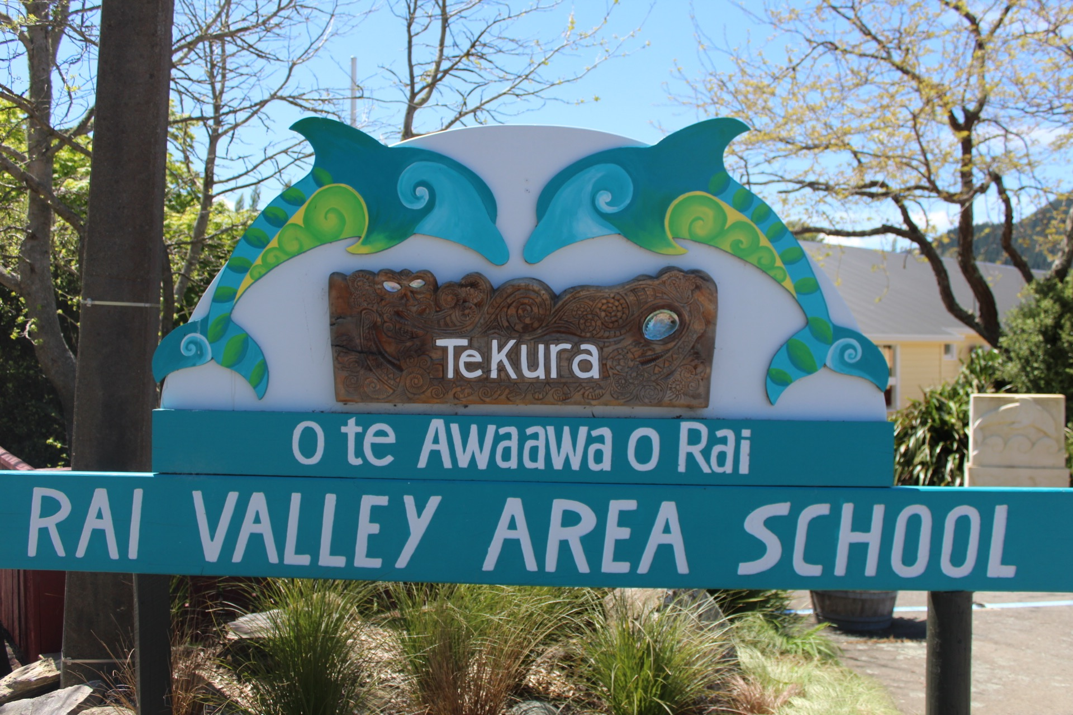

School Statement

Rai Valley Area School is situated in the picturesque Rai Valley approximately 50kms from Nelson and 70kms from Blenheim at the head of the Marlborough Sounds.

Our school is the educational center for all the areas north of the school - Okiwi Bay, Kokoroa and Tennyson Inlet and some of the areas to the south from Havelock and Canvastown.

This Area School serves the needs of five to eighteen year old students throughout the region, as well as supporting pre-school for the wider community. This school is classified U3 with a decile rating of 5.

The school is used by the community and also by groups from Nelson and Blenheim who use our great facilities to hold meetings and functions.

Many of our students come from dairying families, while other families are involved in forestry and the mussel industry.

The school delivers many courses for our senior students to expand their horizons and provide opportunities to participate in experiences outside of the valley. Some examples are our Trades Academy and Gateways programmes. Individualised programmes are developed in conjunction with students and parents.

Close co-operation exists between the five schools in the Pelorus Cluster, and we are part of the active New Zealand Area Schools network and Top of the South Area Schools (TOSI). The school participates in many annual sports tournaments and leadership courses for students.

Our buildings and grounds are well cared for by a dedicated staff of a caretaker and cleaners. There is a well-constructed maintenance plan and buildings are continually being upgraded.

Our school is actively seeking to provide our students with the very best education available while expecting them to achieve to their highest potential. We are a Positive Behaviour for Learning School (PB4L) and promote the Rai Valley (Respect Achieve Inspire).

The stakeholders of our school; students, staff, BOT and parents/whanau, are its greatest assets. Our school continues to strive to be an education provider that students are proud to be associated with.

Growing and Learning towards a Great Future

3

Rai Valley Area School Strategic Goals are:

Student Achievement

Students at
Rai Valley Area School
are able to access
the NZ curriculum and
will look at strategies to
enhance
opportunities

Communication

To strengthen community links and participation through effective communication

Celebrating Student Success

To encourage student leadership and involvement in school and community
Well Being

To ensure all students
gain the necessary
support to enhance their
learning and personal
development

4

Maori Achievement O te Awaawa O Rai Statement

Rai Valley Area School, as appropriate to its community, will develop procedures and practices that reflect New Zealand’s cultural diversity and the unique position of the Maori culture.

In recognising the unique position held by Maori, Rai Valley Area School will take all reasonable steps to provide instruction in Tikanga Maori (Maori culture) and Te Reo Maori (Maori Language).

To achieve this Rai Valley Area School will:

- Support students learning Maori both on site and using offsite providers eg; Correspondence School and or digital providers.

- Use everyday greetings from the Maori language.

- Provide resources in each classroom that supports learning of things Maori.

- Incorporate the use of Maori Language (eg: Waiata and National Anthem) in formal school ceremonies (assemblies, prize giving).

- Foster the development of relationships with local Iwi.

- Invite local Maori artisans and musicians to be part of school activities such as arts and cultural week.

- Develop working relationships with local resource people such as the Maori Advisors and local tutors.

- Explain existing programmes to the school community and further extend the existing programmes if and as appropriate.

Growing and Learning towards a Great Future

5

Special Needs/Abilities Achievement Statement

At Rai Valley Area School, we aim for ALL children to experience educational success and achievement irrespective of their ability. Every child has the right to learn and be part of a welcoming, nurturing and safe environment. At our school we foster and encourage collegial, supportive relationships between all stakeholders invested in children’s education to ensure the best possible learning experiences for them. Collaborative partnerships would include the child, the parents/caregivers, whanau, teachers and/or principal and agencies and servicers which support students with special education needs (eg: Child Youth and Family, Resource Teacher or Learning and Behaviour).

Special Educational Needs/Abilities can be for those children who have difficulty accessing the curriculum at their chronological age/level or for those children whose skills and talents exceed the curriculum expectation associated with their age/level. Rai Valley Area School will maintain a Special Educational Needs Register (including those children with special abilities) to ensure that those children who require additional learning support and/or extension are recorded and having their needs met.

We will endeavor to:

- Gather, collate and review data, progress and achievement of students on the Special Needs Register.
- Use external agencies and expertise to provide additional support and/or funding to assist children. This may include (but is not limited to) Child Youth and Family, Resource Teacher of Learning and Behaviour, Resource Teacher of Literacy, Ministry of Education specialists, Public Health, The Correspondence School, Health Camp.
- Use of Teacher Aides to support and facilitate support or extension programmes, either in class or withdrawal. Programmes may include: Jolly Phonics, Early Words, Rainbow Reading, Maths support.
- Utilise a Learning Support Teacher to work alongside those children requiring additional learning support, in particular, those groups of children identified through the annual School Targets.
- Provision of a Management Unit for Special Needs Coordinator to oversee the coordination responsibilities. Timely Individual Education Plans (when required) to provide planning and review of students learning. Working with parents/caregivers to support their children with their learning.

Growing and Learning towards a Great Future

6
The Rai Way
Respect Achieve Inspire

This is a behaviour management programme designed to enhance learning. It was introduced into Rai Valley Area School in 2014 and is a five year and beyond journey.

The RAI Way explicitly teaches behaviour expectations with rewards for appropriate behaviour and consequences for inappropriate behaviour. The emphasis is on maintaining positive relationships between people and reteaching rather than punishing.

In practice it enables effective instruction to take place, reducing problem behaviours and increasing school safety and predictability.

We have rules for:
- The School
- The Classroom
- To and from school
- The Grounds

Your child should be able to tell you about our RAI rewards.

If you would like to know more you could visit the following web site:

www.positivebehaviourforlearning.co.nz or speak to your child’s teacher.

Growing and Learning towards a Great Future

7

Strategic Goals for 2018 – 2020
This school has started analysing school wide achievement information and has identified the following Strategic Goals:
8

Growing and Learning towards a Great Future

Strategic Goal | 2018 Development | 2019 Consolidate | 2020 Maintain
- Students at RVAS are able to access the New Zealand Curriculum and will look at strategies to enhance opportunities. | Increase PB4L in the school and have local Community involvement.  To start implementing Level two tier status.  To continue implementing Restorative Practice in the school.  Continue to promote Enviro practices within the School and in our local Community.  To investigate hard to staff areas with the use of specialist teachers eg music.  To embed our Community of Learning Schools (Kahui Ako) and continue with PD.  Provide accelerated learning opportunities to students performing below expectations.  Ensure Maori students are engaged in their learning. Analyse Data. Continue with the Maori Action Plan. | Fully implement PB4L-Tier 2.  To gain Gold Status.  Build up an enhanced relationship with Doc / Landcare Trust/Local iwi.  Implement PD within the cluster of Schools.  Investigate using a teacher aide or learning support teacher for block teaching. | Full implementation Tier 1 & 2 and gain Level 3 tier status.  To embed Enviro Schools into RVAS.
- Effective Communication. To strengthen Community links and participation through effective communication. | To continue “good news” stories and community links.  To enhance Community/Parent participation on the BOT.  To ensure the community is aware of the Kahui Ako (TOSI).  To promote the Rai “App” that can let parents know of events happening.  To continue to ring parents when important meetings are taking place if no communication has been received via newsletter/notices etc.
3. Celebrating Student Success. To encourage student leadership and involvement in school and  Community events. | To keep parents informed of the PB4L/Restorative Programme.  To celebrate student success in ways which increase student motivation, achievement and visibility in the Community.  To continue inviting inspirational speakers in to the School.  To continue supporting student led activities eg Leo Club/School Council etc.
4. Well Being  To ensure all students gain the necessary  support to enhance their learning and personal development | Enhance the Well-Being culture of the School and inform parents on our philosophy and safety. | Continue implementing and provide Professional Development.

9

Growing and Learning towards a Great Future

Annual Targets 2018

Growing and Learning towards a Great Future

Our Annual Targets for 2018 will align to our Kahui Ako Achievement Challenges.

- Raising the achievement in Writing for Maori and boys from Yr 1 – 10
- Acceleration of learning in Reading for students after 40 weeks at school
- Raising the Achievement in Mathematics from Yr 4 – 8
- Raising NCEA Achievement at Level 2 and 3 and or UE (retention and engagement)

Refer to Change and Improvement Plan for Rai Valley and the TOSI Community of Learning Achievement Challenges.

10
Change and Improvement Plan for Rai Valley Area School
Challenges Present Situation 2017
Year 1 Reading | - At the end of one year at school, 100% (7/7) are achieving At or Above against National Standards in Reading.  - 100% (0) are Below or Well Below against National Standards.  - 100% of children attend ECE of one form or another
Achievement – Primary (Years 1-8) | National Standards: 2017  Reading:  - 78% students achieve at or above National Standard in writing-53/68 students.  - In Years 1-8, (78%) for boys (24/31) are achieving. This means that 22% (7/31) of boys are not achieving.  - In Years 1-8, (69%) of Maori students are achieving (9/13), 30% (4/13) for Maori students are not achieving.  Mathematics:  - 81% (55/68) of Year 1-8 students achieve at or above the National Standard for mathematics. This means that 19% (13/68) are not achieving at the National Standard.  - For Year 1-8 students, 84% (36/43) of students are at or above the National Standard in mathematics. This means that 16% (7/43) are not achieving.  Writing:  - 71% for boys (22/31) are achieving in writing.  - 29% of boys (9/31) are not achieving at their expected level in writing  - 77% of Maori (10/13) are achieving in writing  - 23% of Maori (3/13)are not achieving in writing
Achievement – Yr 9/10 & NCEA Secondary  2017 | Mathematics:  - In Yr 9/10 (16 /19) are at the Curriculum level (84%)  - In Yr 9/10 (16 /19) are at the Curriculum level (66%) Maori  English:  - In Yr 9/10 (14/19) (74%) are at the Curriculum level.  - In Yr 9/10 (3/6) (50%) of Maori are at or above.  NCEA:  - 100% of 18 year olds leave school with Level 2 – above National targets  - 100% Students with Level 1 or above at Yr 11.  - 100% Students with Level 2 or above at Yr 12.  - 100% Students with Level 3 UE at Yr 13.  - 60% gained UE
Engagement | - Suspension rates across school is low but has been used in 2017  - Retention of senior secondary students would indicate a lower level of engagement at this level or different pathways.  - Varying degrees of transience for different levels all impact to some degree.  11
Other | - Mobility of staff e.g. turnover, subject specialist in isolation etc.  - Geographic isolation  - Inability to access local PLD provisions in some cases  - Staffing costs to access courses  - Accessing relievers so teachers can attend PD  - Scarcity of ‘local’ PLD opportunities  - Increased costs associated with PLD, staffing etc.

12

Growing and Learning towards a Great Future

13
Challenge Areas: | 2017 Current status | 2018 Goal
- Acceleration of learning in Reading for students after 40 weeks at school | - At the end of one year at school, ( 100%) students at or above | - At the end of one year at school 85% of students will be at or above the standard.
- Writing achievement up to Y10 (Maori and boys) | - 71% (31) of boys 2017 are at or above National Standard for Writing in Years 1-8.  - 77% (10/13) of Maori boys at or above National Standard for Writing in Years 1-8.  - 80% of boys in Years 9-10 at or above the expected curriculum level.  - 80% of Maori in Years 9-10 at or above the expected curriculum level. | - 85% of boys at or above National Standard for Writing in Years 1-8.  - 85% of Maori students at or above National Standard for Writing in Years 1-8.  - 80% of boys in Years 9-10 at or above the expected curriculum level.  - 80% of Maori in Years 9-10 at or above the expected curriculum level.
- Mathematics achievement Y4-8 | - 81% (55/68) of Year 1-8 students achieve at or above the National Standard for mathematics. This means that 19% (13/68) are not achieving at the National Standard.  - 84% (36/43) Yr4-8 at or above in Maths. | - 85% of Year 4-8 students at or above the National Standard for mathematics.
- Achievement at Level 3 and/or UE (retention and engagement) | - Lift our NCEA Level 3/UE to 50% (Awaiting results) | - Lift our NCEA Level 3/UE outcomes to 50% of students achieving.

Growing and Learning towards a Great Future

Outcome 1: Acceleration of learning in Reading for students after 40 weeks at school

Current Status: 2017  At the end of one year at school 100%are achieving at or above the National Standards in Reading | 2018 Goal (s)  At the end of one year at school 85% are achieving at or above the National Standards in Reading.
Actions to meet the outcome | What we will see happening differently
- Collaboration of CoL NE teachers  - Identify common data sources across CoL  - Workshops for parents/whanau for reading  - PLD for teachers  - Collaborate with ECE centres  - Develop transition processes | - Online or face to face collaboration  - Engagement with families/whanau, home and school partnerships  - Reading Together programmes in action  - Network and collaboration of CoL New Entrant and related staff  - Collaborative relationship developed for sharing of student information between the CoL Schools and ECE Centres  - Unpacking and understanding of the Te Whaariki curriculum  - Engaging priority male learners  - Visit by ECE teachers  - More formal ECE lessons

Results: 7 students were graded for National Standards. Of those 100% were at or above the standard.

14

Growing and Learning towards a Great Future

Outcome 2 Raising the achievement in Writing for Maori and boys from Year 1 – 10

Current Status: End of 2017  In Years 1-8, for boys (71%) are achieving.  In Years 1-8, of Maori students are achieving (77%).  In Years 9-10, 74% for boys are achieving in writing.  In Years 9-10, 50% of Maori are achieving in writing | 2018 Goal (s)  - 85% of boys at or above National Standard for Writing in Years 1-8  - 85% of Maori students at or above National Standard for Writing in Years 1-8.  - 80% of boys in Years 9-10 at or above the expected curriculum level.  - 80% of Maori in Years 9-10 at or above the expected curriculum level.
Actions to meet the outcome | What will we see happening differently?
- Understanding of progression across levels and schools  - Across school moderation  - Monitoring meetings for meeting needs of target students  - Identifying common assessment strategies used in Year 9-10 CoL-wide  - PLD for teachers  - Workshops for parents/whanau  - Promote parent/whanau participation in student learning | - Ongoing collaboration within and between schools, including ECE and tertiary, to understand progressions needed  - Ongoing moderation within the schools and CoL  - Common standards and assessment practices used  - Improvements in standards and attitude towards literacy  - PLD on effective literacy practices  - Targeted literacy practices in Year 9 and 10  - Based assessments on Literacy Learning Progressions / curriculum level expectations (Year 9 – Level 5B; Year 10 – Level 5P)  - Ongoing skills workshops for students and teachers  - Providing meaningful experiences and purposes – authentic learning  - Flexible grouping based on needs not age or year level  - ALL (Accelerated Literacy Learning) practices implemented across CoL

15
2017 Results:

Yr 1 - 6 Boys 100% at or above National Standard  Yr 1 - 6 Boys 100% at or above NS (Maori students)  Yr 2 - 7 Boys 100% at or above National Standards  Yr 2 - 7 Boys 100% at or above NS (Maori students) | Yr 3 - 3 Boys 33% at or above National Standards  Yr 3 Boys No Maori Students  Yr 4 - 5 Boys 60% at or above National Standards  Yr 4 - 5 Boys 0% at or above NS (Maori)  Yr 5 - 3 Boys 100% at or above National Standards
Yr 6 – 5 Boys 40% at or above National Standard  Yr 6 – 5 Boys 100% at or above NS (Maori students)  Yr 7 – 4 Boys 75% at or above National Standard | Yr 8 – 2 Boys 50% at or above National Standards  0% at or above NS (Maori) (1 student)  Yr 9 – 2 Boys 66% at or above National Standards  Yr 9 – 2 Boys 66% at or above NS (Maori)  Yr 10 – 7 Boys At or above National Standards or expected Curriculum Level  Yr 10 – 1 Boy At or above NS (Maori)  Yr 10 – 3 Boys (47%) At or above National Standards or Curriculum Level.

Growing and Learning towards a Great Future

16

Outcome 3 Raising the achievement in Mathematics from Year 4 - 8

Current Status: At the end of 2017  For Year 4-8 students, 84% of students are at or above the National Standard. | 2018 Goal (s)  85% of Year 4-8 students at or above the National Standard for mathematics.
Actions to meet the outcome | What we will see happening differently
- Across schools moderation/OTJ consistency  - Development of rich tasks/pedagogy  - Common understanding of National Standards and progression through stages  - Workshops for parents/whanau  - Termly monitoring, reviewing and tracking progress of target students  - Using data more effectively to tailor individual learning programmes | - Common standards and assessment practices across CoL with moderation between schools  - Targeted PLD opportunities for staff within and between schools  - Maths workshops for parents  - Understanding fixed/growth mindset practice and the relationship to mathematics development  - Rich tasks/cross curricular/real life contexts  - ALiM (Accelerated Learning in Mathematics) practices implemented cross CoL  - Student progress is tracked regularly through formal meeting process  - Effective data use informing teaching/learning programme development

2017 Results:

Yr 8 – 6 students 66% at or above National Standards
Yr 7 –11 students 64% at or above National Standards
Yr 6 - 7 students 71% at or above National Standards
Yr 5 – 10 students 80% at or above National Standards
Yr 4 - 9 students 100% at or above National Standards

17

Outcome 4 Raising the Achievement at Level 3 and/or UE (retention and engagement)
Current Status: At the end of 2017  Overall, 100% of students achieved NCEA Level 3 at Yr 13.  This means that 0% do not achieve Level 3.  100% of 18 year olds gain Level 2 or equivalent.  60% Gained UE. | 2018 Goal (s)  Lift our NCEA Level 3/UE and outcomes to 50% of students achieving.
Actions to meet the outcome | What we will see happening differently
- Collaboration between teachers throughout the CoL  - Developing and refining of effective mentoring programme for students; inclusion of parents/whanau  - Across school moderation  - Exploring secondary-tertiary pathways  - Online collaboration of secondary subjects across CoL  - Improving outcomes for the Year 9-10 cohort to raise their achievement, goal setting and pathway direction to improve retention, engagement and outcomes of Years 12 and 13  - Exploring secondary-tertiary initiatives for Year 12-13 students | - Effective support for Youth Guarantee opportunities  - Enhanced school based systems for vocational pathways  - Use of CoL expertise for the development of curriculum coverage  - Differentiation of curriculum options for Years 12 and 13  - Targeted mentor/career/guidance programmes available to students  - Combined CoL visits for students to tertiary providers

Results:

5 Students were in Yr 13 this year (2017). All were aiming for Level 3 and 3 for UE.

We achieved this. 100% gained NCEA Level 3 at Yr 13.

Growing and Learning towards a Great Future

18
Top of the South Island (Area Schools)
Community of Learning

Achievement Challenge Plan (2015 – 2018)
Our vision:
Excellence in rural education. Innovative collaboration delivering quality achievement outcomes for all learners in and across the Top of the South Island Area School network.

- Refer to Achievement challenge Plan sent to MOE for more information.
19
20
Our Challenges … At a Glance
BACKGROUND:

The Top of the South Community of Learning is a group of five schools comprising:
- Karamea Area School
- Murchison Area School
- Rai Valley Area School
- Reefton Area School
- South Westland Area School

The original Area School cluster contained seven schools and this cluster will continue to work together on existing joint ventures, including the annual Top of the South Island (TOSI) Tournament in Term 1. Six of the seven schools agreed to form a CoL. Each school agreed to share data to establish base levels of information around each challenge foci and has agreed to a privacy agreement as part of this process. The privacy agreement will be formalised when the Memorandum of Agreement is signed.

The principals at each school belong to various associations including the Top of the South Secondary Principals Association; West Coast and Area Schools Association; Marlborough Principals Association to name but a few.

Each school is small and isolated geographically. All are area schools, catering for students in the Years 1 to 13. The combined roll of our schools is approximately 700 students with 130 of these being in Years 11-13. About 15% of the overall population of students is Māori, ranging from 6-27% in individual schools. Pasifika make up approximately 2% of the overall population. Staffing entitlement is currently approximately 70 FTTE across the schools.

 | 1 July 2015 total roll | Māori | Pasifika | Asian | Other | European \ Pākehā
Collingwood Area School | 122 | 13 | 1 | 4 | 1 | 103
Karamea Area School | 79 | 8 | 1 | 0 | 0 | 70
Murchison Area School | 123 | 15 | 2 | 0 | 0 | 106
Rai Valley Area School | 92 | 25 | 0 | 0 | 3 | 64
Reefton Area School | 185 | 35 | 7 | 19 | 2 | 122
South Westland Area School | 98 | 6 | 3 | 7 | 0 | 82
CoL Total | 699 | 102 | 14 | 30 | 6 | 547

Geographically the schools span a distance of approximately 500 kilometres. Each school services their local community and each has its own unique identity and characteristics. However, as each is an Area School there are a large number of commonalities between them, not least the isolation and size factors they face. The schools have already been working together as an effective cluster for more than 10 years and it is important to the group that this relationship is maintained. As noted
21
in ERO’s summary report, the remote nature of our schools means that there are fewer opportunities for professional development and contact with teachers from other schools. It also impacts on the recruitment and retention of quality staffing.

Over the previous ten years, the schools’ principals have all met regularly for professional learning, planning of shared Tournament weeks, and for the PLD of targeted school staff members, including the Executive Officers, SENCOs and Mathematics teachers. This practice will continue and strengthen through the COL, building on an already strong existing base. There is also a strong link between the schools through the use of WestNet video conferencing and shared teaching practices. The strongest link, perhaps, is through the annual Area School Tournament, hosted by each school in rotation. This event is held in Term 1 each year and is the highlight of many of the students who attend each school. Students can also compete at the National Area School Tournament if selected as part of a team. The Board of Trustees, Principals, and Teachers all have strong links to the NZ Area Schools’ Association. Maths collaboration across the cluster is an example of where the sharing of expertise has significantly improved outcomes.

ERO SUMMARY REPORT

ERO have provided the following Strengths and Area for Improvement summary from recent ERO Reports (based on reports from 2012 – 2015):

General Strengths:
- Meeting the needs of each student through small classes, extra support and individual programmes
- Offering a good range of learning opportunities to students
- Using the community and wider environment to enhance student activities
- Making good use of education outside the classroom programmes
- Holding regular sporting and cultural events with neighbouring schools (and each other)
- Emphasising values and expectations for learning and behaviour
- Having an emphasis on the development of social and self-management skills
- Positive reciprocal relationships with parents and the wider community
- Curriculum: Schools are developing a range of initiatives to provide improved outcomes for students , including:
- Formalising teaching as inquiry to improve the consistency of quality teaching and learning across the school
- Developing modern learning spaces and practices
- Extending the ways technology can support students, parents and staff

General Areas for Improvement:
- More closely track progress of individual priority students
- Strengthening processes for monitoring student progress, across all year levels in the CoL, but particularly at Years 9 and 10
- Evaluating the impact of programmes and strategies for accelerating student progress
- Formalising teaching as inquiry to improve the consistency of quality teaching and learning
22
- Setting more explicit goals and targets for Māori student achievement
- Provide ongoing PLD for staff to better promote Māori students’ success and develop strategies to strengthen involvement of Māori whānau
- Strengthening some aspects of school leadership
- Increasing focus on self-review
  - More formally documenting the process and the outcome of review
  - Implementing regular, planned self-review and evaluation against strategic goals, targets and new initiatives
  - Developing clear expectations and process for self-review

- Learning:
  - More closely tracking progress of individual priority students
  - Supporting teachers to make greater use of achievement data when designing learning programmes so that identified student needs are met
  - Developing and refining moderation processes for OTJs
  - Improving processes for monitoring and reporting student progress, particularly in Years 9 and 10
  - Strengthening reporting to parents to ensure they get accurate and clear information about the progress students are making towards National Standards, including useful ways to help students at home
  - Promoting parent participation in students’ learning, particularly those requiring additional support
  - Increasing evaluation of the impact of programmes and strategies for accelrating students

At this point in time our local ECE centres have not been involved within the CoL process. However, given the focus of the first goal in improving readiness for learning of students coming into schools, close liaison with these institutions is the natural next step.

What has the TOSI CoL already achieved?
- Good working relationships have been established within the TOSI group over the last 10 years
- Firmly developed relationship of working collaboratively
- Establishment of teaching as inquiry practices
- Support for the development of school based NZC learning programmes and documentation
- Establishment of subject, curriculum and pastoral system clusters
Strengths of the TOSI CoL:
- Willingness to collaborate/similar sizes and strengths/concerns
- Support and help for all staff members at different times

Areas which will need attention:
- Retaining senior students with good robust programmes which develop strategies to support transient students
- Ensuring TOSI activities and functions are integrated into our CoL
23
Process of Engagement (during 2015):
- Met once per term and kept Staff / BoT / Community up to date
- A joint BoT powerpoint presentation
- Newsletter articles
- Monthly feedback for each school’s newsletter

How will we report?
- The COL will report to each Board of Trustees twice per year and will provide feedback on progress for them and for the Community.

OUR ACHIEVEMENT CHALLENGES

During 2015 the Top of the South Island Area School boards of trustees and principals met to discuss forming a Community of Learning. The six schools in the CoL submitted an expression of interest to form a CoL which the Minister of Education subsequently approved.

The principals met to discuss how the CoL would work and to share achievement challenges. We initially brainstormed the achievement areas of most concern for each school and then looked for common achievement challenges. This gave us a sense that the achievement of Māori students and boys was a consistent challenge across the CoL. We also identified achievement in Mathematics and Reading (in the first year at school) as being a challenge. When we discussed our leavers (for employment or further education) we noticed that most students were achieving NCEA Level 2 but that fewer were aspiring to and achieving NCEA Level 3 and University Entrance.

A sub group of principals met to sharpen the focus of the challenges. This included analysing achievement data (National Standards, secondary school leavers’ data and data each school held about achievement in writing in years 9 and 10) and engagement data. This analysis confirmed our initial views and from this we identified the following draft achievement challenges. High level actions to address these challenges were discussed and built into our plan.

- Reading after one year at school
- Writing for Māori students and boys from years 1-10
- Mathematics for all students from years 4-8
- NCEA Level 3 and University Entrance

Early in 2016 we updated our analysis to include 2015 National Standards data and extended the analysis to include gender within ethnicity. This confirmed the draft achievement challenges (from 2015) with the exception of Writing from Years 1-8. When we analysed gender within ethnicity it confirmed that from Years 1-8 boys (68%) are achieving below girls (76%) but that achievement is equitable across ethnic groups (see Appendix 2). Our first writing challenge was adjusted to focus on Years 1-10 boys and Years 9-10 Māori girls.
24
Secondary school leavers’ provisional data became available in early May 2016. This showed that the 2015 leavers had achieved at higher levels than the leavers that left during 2014. 87% (34/39) of 2015 leavers had achieved NCEA Level 2 (or better) which exceeds the Better Public Service target for 2017. However, we are mindful that our small leaving cohort means that NCEA Levels 2/3 and UE achievement can fluctuate from year to year and we chose to retain NCEA Level 2 as an achievement challenge (along with NCEA Level 3 and UE).

We think it is important for the CoL to tackle these achievement challenges for a variety of reasons. Students attending the Top of the South Island Area Schools need to have confidence that they can achieve as well as (or better) students attending other schools. It is important that all students leaving the Top of the South Area Schools are positioned to meet the demands of life-long learning. Students leaving our schools need to be well placed to take advantage of future pathways. This requires them to be literate, numerate, meeting success with key competencies and achieving highly on the New Zealand Qualifications Framework (NQF). This is why we have chosen as a first priority to tackle achievement challenges in reading, writing and maths and to use student focused methodology to help our leavers aspire to and achieve highly on the NQF.

Over several years we have noticed a pattern of achievement in reading after 40 weeks at school being significantly lower than after 2 years at school. If we are successful in enabling more students to achieve at (or above) the standard for reading after one year at school then this will result in an even greater level of accelerated progress during the students’ pathway through the school.
We will want to know how we are progressing towards our achievement challenge goals. Establishing a robust and consistent moderation of assessment within and across schools will help with this. It is proposed that within a school, teachers will meet with lead teachers at least once a term to provide information about actions for targeted students and the achievement gains that have been made. Every term individual schools will provide updated progress and achievement data on the targeted students and cohorts to the schools’ board and to the CoL. This will show if accelerated learning is happening for priority learners and cohorts, and will inform new inquiry to support achievement targets being met or exceeded. We will also seek evidence that there is strength in governance monitoring of student achievement outcomes, development in school-wide pedagogical practice across the cluster and development towards high levels of professional content knowledge.

24
Change and Improvement Plan for TOSI Community of Learning
Current Situation (2015)
Year 1 Reading | - After 40 weeks at school, 57% (39/68) of students are achieving at or above against National Standard for Reading.  - 43% (29/68) are below or well below against the National Standard for Reading.  - 94.5% of children (4th quarter 2015) attend ECE of one form or another.
Achievement – Primary (Years 1-8) | Writing (Years 1-8):  - 72% (325/450) of students overall achieve at or above National Standard for Writing  - In Years 1-8, 68% of boys (153/224) are achieving at or above the National Standard. This means that 32% (71/224) of boys are achieving below/well below the standard.  Mathematics (Years 1-8):  - 70% (315/450) of Year 1-8 students achieve at or above the National Standard for Mathematics. This means that 30% (135/450) are achieving below/well below the standard.  - For Year 4-8 students, 69% (191/276) of students are at or above the National Standard for Mathematics. This means that 31% (85/276) are achieving below/well below the standard.  Writing (Years 9-10):  - 47% of boys (26/55) are achieving at or above the expected curriculum level for Writing.  - 53% of boys (29/55) are achieving below the expected curriculum level for Writing.  - 55% of Māori girls (6/11) are achieving at or above the expected curriculum level for Writing.  - 45% of Māori girls (5/11) are achieving below the expected curriculum level for Writing.
Achievement – Secondary | NCEA:  - 87% (34/39) of 2015 leavers (based on provisional leavers’ data) achieved NCEA Level 2 or above.  - 41% (16/39) of 2015 leavers (based on provisional leavers’ data) achieved NCEA Level 3 or above.  - 26% (10/39) of 2015 leavers (based on provisional leavers’ data) achieved University Entrance.
Engagement | - Suspension rates across the CoL are low – 3 suspensions and 13 stand-downs during 2014. The rates of suspensions and stand-downs for Māori students are two times that for NZ European/Pākehā students.  - Retention of senior secondary students would indicate a lower level of engagement at this level: In 2014 60.3% of school leavers participated in some form of tertiary study by the age of 19.  - Varying degrees of transience for different schools although all are impacted to some degree by ‘Gypsy Day’ movements: 7.6 % of Māori and 3.1% Pākehā students attended two or more schools between March and November 2013
Other | - Mobility of staff e.g. turnover, subject specialist in isolation etc.  - Geographic isolation  - Inability to access local PLD provisions  - Staffing costs to access courses  - Accessing relievers so teachers can attend PD  - Scarcity of ‘local’ PLD opportunities and increased costs associated with PLD, staffing etc.  25
Outcome 1: Acceleration of learning in Reading for students after 40 weeks at school (See Appendix 1)

Current Status: 2015  At the end of one year at school 57% (39/68) of students are achieving at or above the National Standards for Reading | 2018 Goal  At the end of one year at school 75% (51/68) of students are achieving at or above the National Standards for Reading (a shift of 12 students)
Actions to meet the outcome |  | What we will see happening differently
- Collaboration of CoL NE teachers  - Identify common data sources across CoL  - Workshops for parents/whānau for reading  - PLD for teachers  - Collaborate with ECE centres  - Strengthen transition processes |  | - Online or face to face collaboration  - Stronger engagement with families/whānau, home and school partnerships  - Reading Together programmes in action  - Strengthened network and collaboration of CoL new entrant and related staff  - Collaborative relationship developed for sharing of student information between the CoL Schools and ECE Centres  - Unpacking and understanding of the Te Whāriki curriculum  - Higher levels of engagement from priority male learners  - Visit by ECE teachers  - Strengthened liaison and smoother transition

Current state (2015) – all students at or above the NS for reading after 40 weeks at school |  | 2016 goal |  |  | 2017 goal |  |  | 2018 goal
Number | % | Number | % | % shift | Number | % | % shift | Number | % | % shift
39/68 | 57% | 41/68  +2 | 60% | +3% | 44/68  +3 | 65% | +5% | 51/68  +7 | 75% | +10%
Where are our students and which ones are we targeting?
In 2015 the students that were below or well below the National Standard for reading after 40 weeks at school were in the following schools. These students are now in Year 2.

The students now targeted for this achievement challenge are the 2016 cohort. During 2016 the schools are targeting all students in their first 40 weeks at school. The actions planned for the CoL have yet to be implemented across all schools and progress during 2016 is likely to be less than for 2017 and 2018. In 2017 and 2018 we will be implementing Reading Together programmes and will be initiating stronger and more collaborative relationships with ECE services. In 2014 nationally 65% were at/above the standard. We consider that to achieve 44/68 (65%) in 2017 is achievable but that 51/68 (75%) in 2018 will be a challenging target.
26
Outcome 2 Raising the achievement in Writing for boys in Years 1-10 and for Māori girls from Year 9 – 10 (see Appendices 2,3 and 4)

Current Status: At the end of 2015  In Years 1-8, 68% of boys (153/224) are achieving at or above the National Standard for Writing.  In Years 9-10, 47% for boys (26/55) are achieving at or above the expected curriculum level for Writing.  In Years 9-10, 55% of Māori girls (6/11) are achieving at or above the expected curriculum level for Writing. | 2018 Goal (s)  - 86% (192/224) of boys achieve at or above National Standard for Writing in Years 1-8 (a shift of 39 students).  - 80% of boys (44/55) in Years 9-10 achieve at or above the expected curriculum level for Writing (a shift of 18 students).  - 91% of Māori girls (10/11) in Years 9-10 achieve at or above the expected curriculum level for Writing (a shift of 4 students).
Actions to meet the outcome | What will we see happening differently?
- Understanding of progression across levels and schools  - Across school moderation  - Monitoring meetings for meeting needs of target students  - Identifying common assessment strategies used in Year 9-10 CoL-wide  - PLD for teachers  - Workshops for parents/whanau  - Promote parent/whanau participation in student learning | - Ongoing collaboration within and between schools, including ECE and tertiary, to understand progressions needed  - Ongoing moderation within the schools and CoL  - Common standards and assessment practices used  - Improvements in standards and attitude towards literacy  - PLD on effective literacy practices  - Targeted literacy practices in Year 9 and 10  - Based assessments on Literacy Learning Progressions / curriculum level expectations (Year 9 – Level 5B; Year 10 – Level 5P)  - Ongoing skills workshops for students and teachers  - Providing meaningful experiences and purposes – authentic learning  - Flexible grouping based on needs not age or year level  - ALL (Accelerated Literacy Learning) practices implemented across CoL

Years 1 - 8

Current state (2015) – Year 1-8 boys at or above the NS for Writing |  | 2016 goal |  |  | 2017 goal |  |  | 2018 goal
Number | % | Number | % | % shift | Number | % | % shift | Number | % | % shift
153/224 | 68% | 163/224  +10 | 73% | +5% | 181/224  +18 | 81% | +8% | 192/224  +11 | 86% | +5%

Where are our students and which ones are we targeting?

27

Years 9 - 10

Current state (2015) – Years 9-10 boys at or above the expected curriculum level for Writing |  | 2016 goal |  |  | 2017 goal |  |  | 2018 goal
Number | % | Number | % | % shift | Number | % | % shift | Number | % | % shift
26/55 | 47% | 32/55  +6 | 58% | +11% | 39/55  +7 | 71% | +13% | 44/55  +5 | 80% | +9%

Current state (2015) – Years 9-10 Māori girls at or above the expected curriculum level for Writing |  | 2016 goal |  |  | 2017 goal |  |  | 2018 goal
Number | % | Number | % | % shift | Number | % | % shift | Number | % | % shift
6/11 | 55% | 10/11  +4 | 91% | +36% | 10/11  +0 | 91% | +0% | 10/11  +0 | 91% | +0%

Where are our students and which ones are we targeting?

28
Outcome 3 Raising the achievement in Mathematics for students in Years 4 - 8

Current Status: At the end of 2015  For Year 4-8 students, 69% (191/276) of students are achieving at or above the National Standard. | 2018 Goal (s)  80% of Year 4-8 students (221/276) are achieving at or above the National Standard for mathematics (a shift of 30 students)
Actions to meet the outcome | What we will see happening differently
- Across schools moderation/OTJ consistency  - Development of rich tasks/pedagogy  - Common understanding of National Standards and progression through stages  - Workshops for parents/whanau  - Termly monitoring, reviewing and tracking progress of target students  - Using data more effectively to tailor individual learning programmes | - Common standards and assessment practices across CoL with moderation between schools  - Targeted PLD opportunities for staff within and between schools  - Maths workshops for parents  - Understanding fixed/growth mindset practice and the relationship to mathematics development  - Rich tasks/cross curricular/real life contexts  - ALiM (Accelerated Learning in Mathematics) practices implemented cross CoL  - Student progress is tracked regularly through formal meeting process  - Effective data use informing teaching/learning programme development

Current state (2015) – Year 4-8 students at or above the NS for mathematics |  | 2016 goal |  |  | 2017 goal |  |  | 2018 goal
Number | % | Number | % | % shift | Number | % | % shift | Number | % | % shift
191/276 | 69% | 201/276  +10 | 73% | +4% | 211/276  +10 | 76% | +3% | 221/276  +10 | 80% | +4%

Where are our students and which ones are we targeting?

29
Outcome 4 Raising the level of students leaving school having achieved NCEA Level 2/Level 3 or above (retention and engagement)
Current Status: At the end of 2017 (based on provisional leavers’ data)  Overall, 87% (34/39) of school leavers achieve NCEA Level 2 or above, 41% (16/39) of school leavers achieve NCEA Level 3 or above, and 26 % (10/39) of school leavers achieve University Entrance. | 2018 Goal (s)  100% (39/39) of leavers are achieving NCEA Level 2 (or better) and 56% (22/39) of leavers are achieving NCEA Level 3 (or better), and 46% (18/39) of leavers are achieving University Entrance.
Actions to meet the outcome | What we will see happening differently
- Collaboration between teachers throughout the CoL  - Developing and refining of effective mentoring programme for students; inclusion of parents/whanau  - Across school moderation  - Exploring secondary-tertiary pathways  - Online collaboration of secondary subjects across CoL  - Improving outcomes for the Year 9-10 cohort to raise their achievement, goal setting and pathway direction to improve retention, engagement and outcomes of Years 12 and 13  - Exploring secondary-tertiary initiatives for Year 12-13 students  - Deliver specialist Year 9-10 online learning opportunities to raise the aspirations for students as they move into Years 11-13 | - Effective support for Youth Guarantee opportunities  - Enhanced school based systems for vocational pathways  - Use of CoL expertise for the development of curriculum coverage  - Differentiation of curriculum options for Years 12 and 13  - Targeted mentor/career/guidance programmes available to students  - Combined CoL visits for students to tertiary providers
The tables above show the number and percentage of 2015 leavers that achieved NCEA Level 2/3 or better. The data was provisional at the time this plan was written.

The number of leavers across the CoL is very small (39) and fluctuates from year to year. The small numbers also contribute to year to year fluctuations in leaver achievement within schools and aggregated across the CoL

Our goal for 2016-2018 is for all leavers to achieve NCEA Level 2 or better. Some schools achieved this in 2015. All schools will use student focussed methodology and individual learning plans to target all students in the hope that they achieve NCEA Level 2 before leaving school. Concurrently we will use student focussed methodology and individual learning plans to lift the number and percentage of students aspiring to and achieving University Entrance//NCEA Level 3.
Current state (2015) – School leavers achieving NCEA Level 2 (or above) |  | 2016 goal |  |  | 2017 goal |  |  | 2018 goal
Number | % | Number | % | % shift | Number | % | % shift | Number | % | % shift
34/39 | 87% | 37/39  +3 | 95% | +8% | 39/39  +2 | 100% | +5% | 39/39  +0 | 100% | NA
30

Current state (2015) – School leavers achieving NCEA Level 3 (or above) |  | 2016 goal |  |  | 2017 goal |  |  | 2018 goal
Number | % | Number | % | % shift | Number | % | % shift | Number | % | % shift
16/39 | 41% | 18/39  +2 | 46% | +5% | 20/39  +2 | 51% | +5% | 22/39  +2 | 56% | +5%

Current state (2015) – School leavers achieving University Entrance |  | 2016 goal |  |  | 2017 goal |  |  | 2018 goal
Number | % | Number | % | % shift | Number | % | % shift | Number | % | % shift
10/39 | 26% | 12/39  +2 | 31% | +5% | 15/39  +3 | 38% | +7% | 18/39  +3 | 46% | +8%

Where are our students and which ones are we targeting?

31
APPENDIX 2: 2015 National Standards data for Writing by Ethnicity and Gender (all CoL schools combined)
 |  | Overall Teacher Judgement |  |  |  |  |  |  |  |  | At/Above
 |  | Well below |  | Below |  | At |  | Above |  | Total
 |  | Number | Percent | Number | Percent | Number | Percent | Number | Percent
Māori | Male | 2 | 8.0 | 7 | 28.0 | 15 | 60.0 | 1 | 4.0 | 25 | 64.0
 | Female | 3 | 10.3 | 4 | 13.8 | 17 | 58.6 | 5 | 17.2 | 29 | 75.9
 | Total | 5 | 9.3 | 11 | 20.4 | 32 | 59.3 | 6 | 11.1 | 54 | 70.4
European | Male | 8 | 4.4 | 51 | 28.0 | 94 | 51.6 | 29 | 15.9 | 182 | 67.6
 | Female | 6 | 3.2 | 41 | 22.2 | 88 | 47.6 | 50 | 27.0 | 185 | 74.6
 | Total | 14 | 3.8 | 92 | 25.1 | 182 | 49.6 | 79 | 21.5 | 367 | 71.1
Pasifika | Male | 0 | 0.0 | 0 | 0.0 | 2 | 66.7 | 1 | 33.3 | 3 | 100.0
 | Female | 0 | 0.0 | 0 | 0.0 | 3 | 75.0 | 1 | 25.0 | 4 | 100.0
 | Total | 0 | 0.0 | 0 | 0.0 | 5 | 71.4 | 2 | 28.6 | 7 | 100.0
Asian | Male | 0 | 0.0 | 2 | 20.0 | 6 | 60.0 | 2 | 20.0 | 10 | 80.0
 | Female | 0 | 0.0 | 0 | 0.0 | 4 | 57.1 | 3 | 42.9 | 7 | 100.0
 | Total | 0 | 0.0 | 2 | 11.8 | 10 | 58.8 | 5 | 29.4 | 17 | 88.2
Other | Male | 0 | 0.0 | 1 | 25.0 | 2 | 50.0 | 1 | 25.0 | 4 | 75.0
 | Female | 0 | 0.0 | 0 | 0.0 | 0 | 0.0 | 1 | 100.0 | 1 | 100.0
 | Total | 0 | 0.0 | 1 | 20.0 | 2 | 40.0 | 2 | 40.0 | 5 | 80.0
Total | Male | 10 | 4.5 | 61 | 27.2 | 119 | 53.1 | 34 | 15.2 | 224 | 68.3
 | Female | 9 | 4.0 | 45 | 19.9 | 112 | 49.6 | 60 | 26.5 | 226 | 76.1
 | Total | 19 | 4.2 | 106 | 23.6 | 231 | 51.3 | 94 | 20.9 | 450 | 72.2

32
Charter Consultation 2018
Appendix 1
The Board of Trustees | On-going 2018
Maori Community | Term 2, 2018
School Parents | On-going throughout the year  via Newsletter, Parent Meetings, Surveys/Webpage/Facebook
School Staff | On-going – Staff Meetings / PD
Ministry of Education Website  www.education.govt.nz | On-going
Ministry - “Planning for better student Outcomes” | On-going

Chairperson________________________ Date_________________

Principal___________________________ Date_________________

33

Growing and Learning towards a Great Future

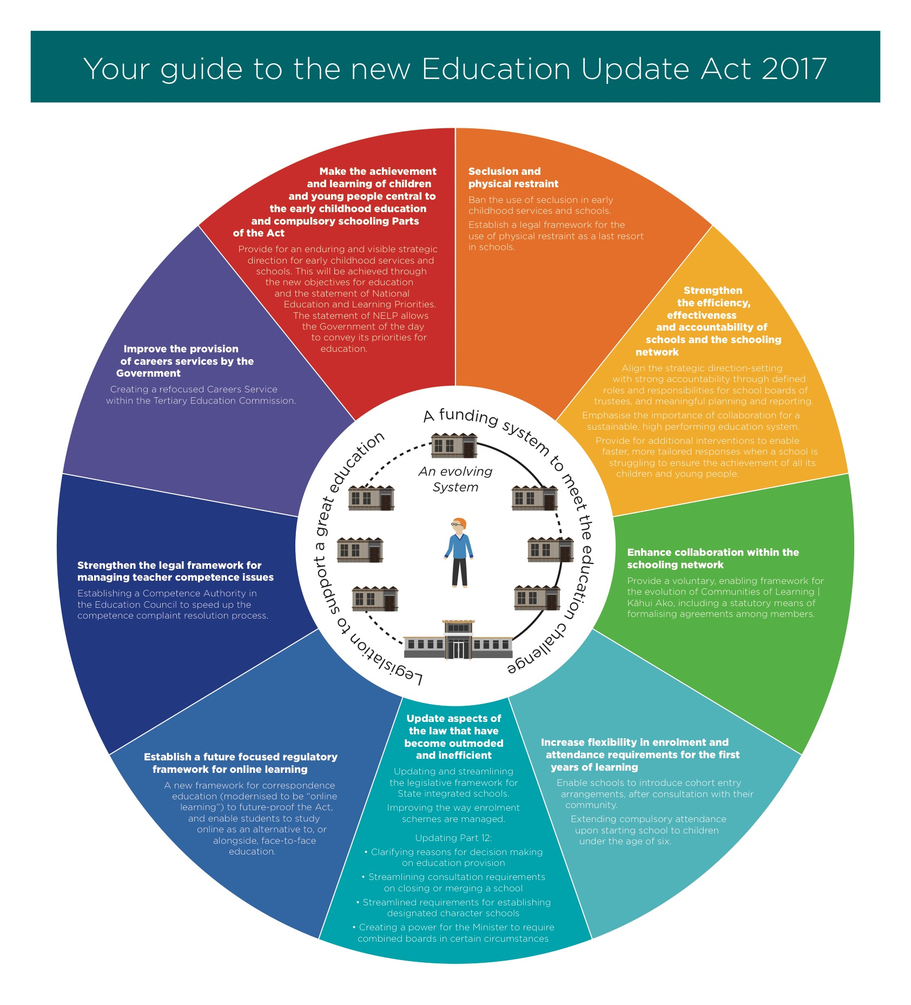
Appendix 2
National Education and Learning Priorities

34
Supporting Documentation

Appendix 3
Rai Valley Area School Policy and Procedures

Curriculum Programme
Assessment
Achievement of Maori Students
Guidance
Class Programmes and Delivery

Rai Valley Area School Policy and Procedures

Strategic Planning
Self Review
Reporting to Students, Parents and School Community

Rai Valley Area School Policy and Procedures

Annual Development Plan
Appraisal and Teacher performance
Employment – good employer and EEO

Rai Valley Area School Policy and Procedures

Annual Budget
Administration
10 year Property Plan

Rai Valley Area School Policy and Procedures

Health and Safety including - Physical and Emotional
- Healthy Food and Nutrition

Rai Valley Area School Policy and Procedures

General legislation - Attendance
- Length of School day
- Length of School year

35

Growing and Learning towards a Great Future

Annual Timeline

Appendix 4

Charter - copy to the MOE by 1st March each year

Accounts Audited - to the MOE by 31st May

Analysis of Variance - Year 1-8 to MOE by 1st March

Annual Report - this includes the Analysis of Variance 31st May

Reporting to Parents - twice yearly in writing
- at least once orally

Consultation - (ongoing) with local community

Targets for achievement identified

36

Growing and Learning towards a Great Future

Procedural Information

Appendix 5

Rai Valley Area School will lodge a copy of its annually updated Charter to the Ministry of Education by 1st March 2017.

Rai Valley Area School will lodge a copy of its Annual Targets to the Ministry of Education by 31st May.

Rai Valley Area School will consult with its community as part of its cycle of self-review. This consultation may include:
- Consultation by the Board of Trustees
- Invitations to school families to attend Board meetings.
- All surveys and questionnaires are given to families.
- Maori families will be consulted on the Maori programme, curriculum issues and their aspirations for their children.
Targets for student achievement will be identified by:
- Analysis of school wide assessment data
- Identifying areas of needed development from data and discussion
- National Curriculum Goals.
- The National Standards

Performance Management
The schools procedures and guidelines relating to Appraisal and Performance Management will be adhered to. For 2017 the focus of this process (including classroom observation) will be on Numeracy, Writing, Reading and NCEA. This process and these observations also tie into our Curriculum Development Focus.
Self Review
Every year the BOT reviews its work through committees and there is a review of teaching and learning. The Strategic Plan and the Annual Plan are reviewed as well. Curriculum Review is also done annually. A Parent Survey is carried out each year to gather data for review.
Finance and Assets
The BOT receives a report at BOT meetings, which details the expenditure against budget expressed as a percentage YTD for all accounts. The report includes account balances and summation of investments.
Health and Safety
The Health Procedure is continually being worked on was updated along with the Hazards Register.

37

Growing and Learning towards a Great Future

Rai Valley Area School- O te Awaawa O Rai
2018
Appendix 6
Annual Plan
Item | Who is Resp | FEB | MAR | APR | MAY | JUNE | JULY | AUG |  | SEPT |  | OCT |  | NOV | DEC

BOARD ADMIN
Review of Nags | BOT
Policy Procedure Review | BOT  Principal. | Review of Documentation of: Personnel, Review, Community Liaison, Finance / Property

CURRICULUM
Planning & Reporting – Student Achievement | Principal & Staff |  | Goal Setting Interviews |  |  |  | Reports Y9-13 | Parent/Teacher  Y9 - 13 |  |  |  |  | Reports  Y1-13
Curriculum  Reports/Reviews  Meeting National Priorities | Curriculum  Teams | Set Curriculum teams  Establish goals | Plan curriculum  Event |  | Complete Programme  Reviews |  |  |  |  |  |  |  | Curriculum  Reviews
Special Needs Programme | Principal & Special Education Co-ordinator | Compile  Special  Needs  Registers |  | IEP’s |  |  |  |  |  |  | IEP’s
Assessment | Principal & Staff | School wide data collected and analysed at the end of each term

PERSONNEL
Principal  Appraisal | Chairperson/  BOT Committee |  |  |  |  |  |  |  |  |  |  |  | Appraisal
Staff Appraisal | Syndicate  Leaders/Principal | Prof Appraisal  Standards Meetings  PD/Goal  Setting |  |  |  |  | Appraisal  Observations  &  Meetings |  | Observations  &  Review
EEO Plan | EEO  Co-ordinator |  | Survey Staff  Set targets |  | Review Code of conduct with staff
Staff  Development | Principal | Ongoing throughout year
BOT  Development |  | Ongoing throughout year

Growing and Learning towards a Great Future

38
ITEM | WHO IS RESP | FEB | MAR |  |  |  | APR | MAY |  | JUNE |  | JUL | AUG |  |  | SEPT |  |  | OCT | NOV |  | DEC

HEALTH & SAFETY
Hazard Identification | BOT  Members with Health & Safety  Responsibility |  | Update Register |  |  |  |  | Awareness and identification ongoing
Budget | Finance Person BOT |  |  |  |  |  |  |  |  |  |  |  |  |  |  |  |  | Budget  Setting  Meetings |  | Budget Set
Annual Financial Statement | Finance Person BOT |  |  |  |  |  |  | Report to  Community  Send to MOE
ASSET MANAGEMENT
Property | Property Person BOT | Monthly monitoring, maintenance and hazard identification
10 Yr Property Plan | Property Person BOT | Review
Evacuation Notification |  | Trial Evacuation |  |  |  |  |  | Trial Evacuation |  |  |  | Trial Evacuation |  |  |  |  |  |  | Trial Evacuation

CONSULTATION
Maori | Principal | Consultation with Community
Community | Principal | Weekly Newsletters, Surveys, Public Meetings, ongoing as the need/opportunity arises
STUDENT ACTIVITIES | Staff & Students | Fundamental Skills  Swimming Sports |  | Tech Challenge  Top Teams |  |  | Area Schools Tournament |  | Science Fair |  | Cross Country |  |  | Maths Week  Life Ed | Theatre Sports Speech  Competition  Choir Festival |  |  |  |  |  | Triathlon  Orienteering Athletics
COMMUNITY BASED EVENTS | Staff & Students & Community | School Information Sessions |  | Rai Valley  A& P Show |  |  |  |  |  |  |  |  |  |  |  |  |  |  | Pet/Flower Show  Spring Fair |  | Prizegiving

Growing and Learning towards a Great Future

39

Curriculum Development
Appendix 7 2018 - 2020

2018 |  | 2019 |  | 2020
What | Who | What | Who | What | Who
Careers  Maori Achievement  NCEA  L1/2/3  ICT Upgrades  Curriculum Development  Trades Academy  EOTC / Health & Safety  PB4L/Restorative  ENVIRO  PACT (Maths) | Angela / Richard  Angela / Annelies / Siobhan  Angela, Siobhan, Mike & Steph/David  Neil, Angela & All Staff  Angela & All Staff  Literacy/Writing/ Maths  Angela & Richard  Angela & All Staff  Richard  Angela S, Mike, Annelies Debby & All Staff  Siobhan, Debby and Annelies  Annelies & Primary Syndicate (Maths) | Careers  Maori Achievement  PACT (Reading) | Angela & All Staff  Angela, All Teachers  Angela | NCEA Level 3  PACT (Writing)

Curriculum Development 2018 Action Plan
40

Growing and Learning towards a Great Future

Curriculum Development 2018 Action Plan
Appendix 8

Area | Objective | Outcome | Who | $ | Report to BOT | Review | PD | Completed Dec 2018
ICT | To have all student access faster internet connections. | Modern / fast access to www available.  BYOD used by students to enhance learning  Video conferencing/hangouts | Neil  Angela | $50.00 per month | Term 2  Term 4 | Each year
Maori Achievement | To raise students literacy and numeracy skills to At or Above average.  To bring Whanau on Board. | All students succeeding at school. | All Staff |  | Term 4 | Each year | Staff meetings  Te Kotahitanga  Resource Teacher of Maori
Trades Academy | To have all Yr 12/13 students leaving school with NCEA Level 2  (and some Yr 11 students) | Improved Career Pathways | Angela & Richard | MOE Funding for 2017 | Report Term 2  Term 4 | Each year | Meetings to attend and Powhiri in Nelson
PB4L/Restorative | To ensure positive learning takes place in school | All students are learning in a safe caring environment | Angela, Mike, Madelein, Annelies and whole staff | $1000.00 | Term 4 | End of Year | Copy tabled at BOT meeting.
Enviro School | To have all students aware of the environment. | All students environmentally aware. | Siobhan  Debby  Annelies | $ 1000.00 | Term 4 | End of Year | Staff meeting  Enviro Officer invited
Careers | To re-look at our Curriculum delivery. | All students have good access to from Yr 8-13. | Richard | $ 1000.00 | Term 2  Term 4 | End of Year | Visit Schools
Maths | CoL contracts refer application |  | Yr 0-8 Siobhan  Yr 9-13 |  | Term 4 | End of Year | Cantebury University

41

Growing and Learning towards a Great Future

Rai Valley Area School

Appendix 9 Five Year Programme of Self Review
Major Area | Year One  2018 | Year Two  2019 | Year Three  2020 | Year Four  2021 | Year Five  2022
- Curriculum and Assessment | Careers  Maths/Literacy | Maori Achievement  EOTC  Trades Academy  Maths | All Curriculum Areas | Social Science  Special Ed/Literacy  Health & PE  Arts | English  Maths
- Documentation  Self Review | BOT Operations  Policy Manual  (to continue ongoing review) | Maori Community Consultation  Charter  Policy/Procedures – Health & Safety | Board Structure  Health Consultation | Charter  Strategic Plan  Self Review  Health consultation  Gov. Policy Manual | Strategic Plan  Annual Plan
- Employer Responsibility | PD | Staff Handbook  PD | Performance Management  PD | EEO Programme  Staff Handbook  Professional Development for staff and BOT | Complaints  PD
- Assets  - Finance  - Property | Budget Procedures  ICT Equipment Plan plus Upgrade | Office Administration  Annual Maintenance  Nelson Loop | Accounting / Cash Handling  Furniture | Asset Register  10 year Property Plan | Income  Cleaning
- Health & Safety | Bus Transport  EOTC | Safety (hazards, accidents, civil defense, evacuation drills, first aid)  Policy / Procedures | Guidance | Discipline  Health & Safety Procedures | School Routines
- Administration | Enrolment | Attendance  Website | Length of day, year | Website | Key Legislation  Website

42

Growing and Learning towards a Great Future

Appendix 10
Curriculum: NAG 1

Major focus: PB4L/Restorative
Careers
Maths
Review: Policy Manual

Policies: Careers/Maths/Literacy
Health & PE and The Arts
Documentation/Self Review NAG 2

BOT Operations
Policy Manual

Mission Statement:

Rai Valley Area School aims:

1.To provide quality education that caters for
the needs of individual students.

2.To continually develop classroom National
Curriculum Statements and emphasis the
teaching of the Key competencies.

School Development Plan
Rai Valley Area School
2018

Property Management NAG 4

Review: Boiler System

Financial Management NAG 4

Review: Budget Procedures
ICT Equipment Plan

Employer Responsibilities NAG 3

Review: PD

Community Partnership & Promotion

Area School Tournament 2018 Karamea
Pelorus Cluster Events
TOSI Events
TOSI Community of Learning

Health & Safety NAG 5

Review:
School Routines

Legislative Requirements & Administration NAG 6

Enrolment

43

Growing and Learning towards a Great Future

